Message from the Practice Manager - Ranjan Patel
Thank you to all our patients, staff – especially Hilary & Margaret and the PPG Members, £400 was raised on 29th September 2017 for Macmillan Cancer

PPG Group
(Patient Participation Group)
• • •
We are a group of 10 interested patients which work with the practice to help look at issues from a patient perspective. We meet at the practice every 3 months to discuss current issues at the Practice which affect patients and any concerns from patients. The Agenda from the August/November meeting included:-
- Appointments & DNA appointments
- Staffing Update
- Flu
- Training
- Reception Waiting Area/Disabled Access
Current members are:-
Chair: Robin Maillard
Deputy Chair:
Roland Hopwood
Barry Ford

And other members
Date of the next PPG Meeting: - 12th February 2018
BEECHWOOD SURGERY NEWSLETTER
www.beechwood-surgery.co.uk
December 2017 |  | Edition 1

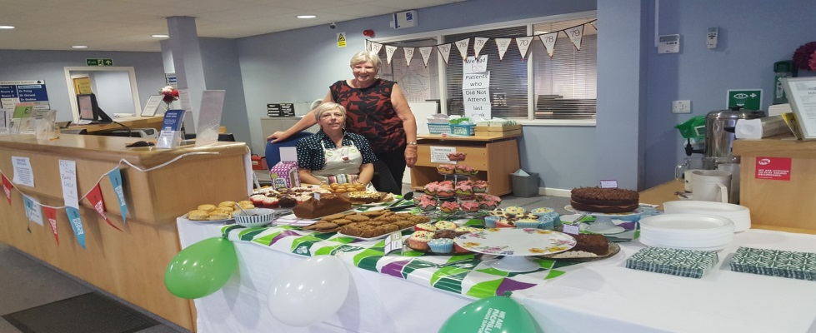
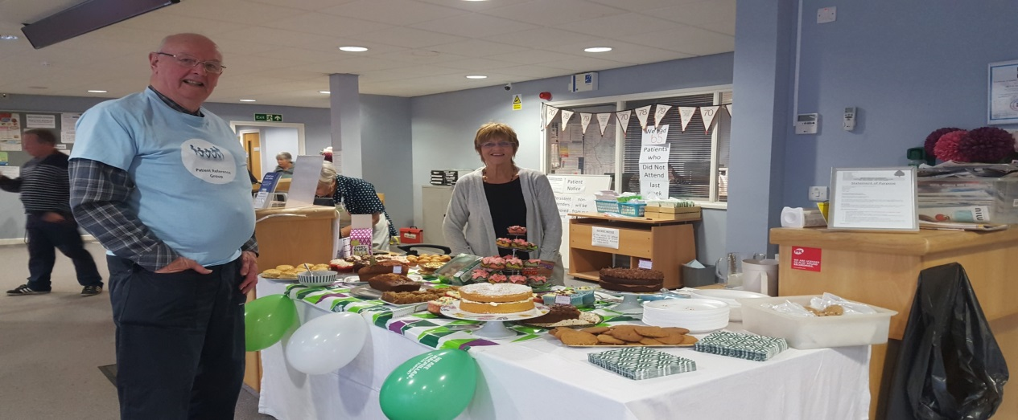

Flu Season is upon us, we hope you find the Minor Elements Leaflet useful– a copy of which can be located on our front desk news area.
Are you 65 or over, asthmatic, diabetic, COPD, have a heart condition, or a carer for somebody? If so, it is not too late to book your appointment for your Flu Jab this year – ask one of our receptionists for further advice and to see if you are eligible for a flu vaccine at Beechwood Surgery today.

New Doctor: - Welcome Dr Emily Evans
New Nurse – Welcome Nurse Rosie Hughes
  - DID YOU KNOW:-

The following services are now based at Beechwood
- AAA Scans
- Diabetic Retinal Screening
- Ultrasound
Alternative Blood Test Venues: - You can book a blood test online at https://www.swiftqueue.com/
you will be asked to select a clinic - these include Billericay Health Centre and Basildon Hospital, Alternatively you can telephone
- 01702 746511
- 01702 746510
- 01702 746509
Walk-in Blood Test Venues
Queens Hospital: 7am-5pm
Harold Wood Polyclinic: 8am – 12pm
Harold Hill Health Centre (Gooshays Drive): 8:45 - 12:00
Orsett Hospital: 8am-3:45pm
St Andrews Centre, Billericay: 11am-1pm
Walk-in X-ray Service
Brentwood Community Hospital 8:30am - 3:30 pm
(Monday to Friday Only)

OTHER SERVICES:-
Harold Wood GP Walk-in Centre
Open from 8am - 8pm (including weekends and all public holidays). It is advisable to telephone to check waiting times and availability if you are planning to attend after 16:00pm
: Tel 01708 574000.
HWPC treat minor illness and injuries and have x-ray facilities. Any injuries presented to the Walk-in Centre after 7:15pm requiring x-ray will be re-directed to Upney (which closes at 10pm) or Queens Hospital. Alternatively you can return the following day.
Medication: Please be aware that they will only prescribe medication necessary for the treatment of minor illnesses and injuries. There are certain medications they do not prescribe as they should only be obtained from your own GP as they can be both addictive and dangerous in high doses.
Orsett Hospital - Minor Injuries Unit (MIU)
Provides comprehensive nurse-led service which deals with a wide range of minor injuries. Wound care can be provided either as part of emergency care or when a review of a wound is required.
X-ray facilities are available from Monday to Friday until 4pm.The x-ray facilities available for patients attending MIU are for the shoulder to the fingers and the knee to the toes only. They do not x-ray children under seven years of age due to the complexity of interpreting their results.
They are open Monday to Sunday from 10:00am to 8:00pm. Bank holidays times may vary. Please contact them on 0300 300 1527 before you visit.
NHS 111 Service
111 is the NHS non-emergency number. It's fast, easy and free. Call 111 and speak to a highly trained adviser, supported by healthcare professionals. They will ask a series of questions to assess your symptoms and immediately direct you to the best medical care for you.
NHS 111 is available 24 hours a day, 365 days a year. Calls are free from landlines and mobiles.
When to use 111
- you need medical help fast but it's not a 999 emergency
- you think you need to go to A&E or need another NHS urgent care service
- you don't know who to call or you don't have a GP to call
- you need health information or reassurance about what to do next.

