BEECHWOOD SURGERY NEWSLETTER
www.beechwood-surgery.co.uk
Quarterly Publication: June 2018 |  | Edition 3

Message from the Practice Manager

  - Carer’s Event: Tuesday 10th July – 3:30pm-6:30pm.
  - Representatives from Alzheimers, Diabetes & SNAP. Plus information from McMillian Everyone welcome.

  - General Data Protection Regulations (GDPR) / Consent Required: Due to new general data protection regulations it has now become necessary to gain written consent form 12-17 years olds to confirm their details and to make informed decisions to allow their parent or guardians to act on their behalf. Please ask at Reception for more information and the required form to complete.

  - Extended Hours Appointments:- There are now limited appointments available weekly with GP's and nurses available in Brentwood. For more information please see overleaf.

  - Dr Sanka: We are sorry to announce that Dr Sanka will be leaving the surgery as of 30th September 2018. We wish to thank him for his dedication to the surgery and we all wish him well for the future.

  - WiFi:We are pleased to advise that we now have wi-fi available in the practice. If you wish to have access to this, please ask at Reception for the password.
Message from PPG

PPG Group
(Patient Participation Group)
• • •
We are a group 10 interested patients which work with the practice to help look at issues from a patient perspective.
We meet at the practice every 3 months to discuss current issues at the Practice which affect patients and any concerns from patients.
Chair:- Robin Maillard
Deputy Chairs:-
- Roland Hopwood
- Barry Ford

To contact PPG via Email: PPG.Beechwood@nhs.net
Date of the next PPG Meeting:- August 2018
The PPG have been discussing the high rate of people who make an appointment to see the doctor and then do not arrive (DNA) without cancelling the appointment. By not coming to the appointment the doctor’s time is wasted and this also affects the waiting time for appointments.
In an effort to improve the situation the surgery has installed a programme that can be used to cancel the appointment when you receive notification of your appointment on your mobile phone. Can we ask for your help that if you do not now need the appointment that you have made then you notify us so that we can use that time to help another patient?
Our doctors, nurses and staff at the surgery do have your best interests at heart and want to be able to treat as many people as possible. We would like to thank you for your co-operation. Regards, Robin
DID YOU KNOW:-
GP’S & NURSES EXTENDED HOURS IN BRENTWOOD
  - There are now limited appointments with GP's and nurses available in Brentwood.
  - Monday to Friday: 6:30 pm - 8:00 pm
Saturday: 9:00 am – 3:00 pm
Sunday: 10:00 am – 2:00 pm

How do I book a GP or nurse appointment?
Contact your GP practice in the usual way to request an appointment. Please note that your consent will be required in order for an appointment to be booked for you. You will be seen by a registered GP’s and nurses.
Service is located at: Brambles Surgery, Greenwich Avenue, just off Geary Drive, Brentwood, Essex CM15 9DY.
Be aware that if you have booked an appointment via this service you will need to cancel your appointment by calling or texting to
07757 719333
Leaving your full name and appointment date and time
  - For more information please ask at Reception or go our website under Latest News- GP Extended Access Bookable Service and download the leaflet.
ON-LINE CONSULTATION WITH YOUR GP
E-consult is a quick and easy way for patients to submit condition-based questionnaires to their own GP, potentially avoiding the need to attend the surgery. Go to Beechwood Surgery website, www.beechwood-surgery.co.uk

The website link will bring you to the Beechwood Surgery Homepage, where the on-line consultation service is available, as shown below. Go to the Section in Green – “Contact our doctors online” and click into the red box – “Get Started Now”. You will then be asked a serious of questions to complete. Once completed and you have submitted the form, this will come directly to the Surgery for the Duty Doctor to review and advise Reception to contact you on the course of action that is required.

For online consultations please click the link below. If you do not hear from us within 48 hours please call the surgery.
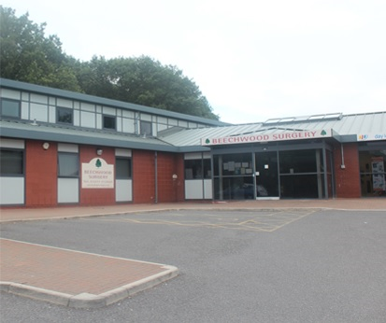 | 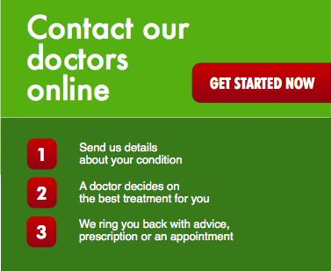
We are confident that our website will provide clear and concise help and give our patients the information they require in an easy and convenient format. It has been designed with the patient’s needs at the forefront of everything, from checking surgery times to letting us know what you think of us.

