Message from the Practice Manager
BEECHWOOD SURGERY NEWSLETTER
www.beechwood-surgery.co.uk
Quarterly Publication: March 2018 |  | Edition 2

  - Heating Issues:
I wish to apologise to all our patients with regards to the heating issues we have been experiencing. Thank you for your patience and understanding.
Patients Not Attending Appointments (DNA)
There were 143 patients that did not attend their appointment in February. If you are unable to attend your appointment, please call the surgery, 2 hours before your appointment and PRESS OPTION 1 and leave your name, date of birth and appointment details. This will enable us to use your appointment for someone else. Thank you
On-Line Access
This service allows you to book and cancel appointments on-line. To enable this service, please visit the surgery with proof of identification and the Receptionist will allocate you a password.

PPG Group
(Patient Participation Group)
• • •
We are a group 10 interested patients which work with the practice to help look at issues from a patient perspective.
We meet at the practice every 3 months to discuss current issues at the Practice which affect patients and any concerns from patients.
Chair:- Robin Maillard
Deputy Chairs:-
- Roland Hopwood
- Barry Ford

To contact PPG via Email: PPG.Beechwood@nhs.net
Date of the next PPG Meeting:- May 2018
ARE YOU A CARER?
If so, please let us know by filling out one of our forms at the Front Reception Desk and hand it to the Receptionist who will provide you with an information pack.
Message from PPG
Type 2 Diabetes is a condition that is increasing in our population. It is possible to live well with Diabetes and to cope with this condition.
There is a lot of help from the doctors and specialist diabetes nurses but that can only go so far because that patient has to learn to live with the condition. To assist with this learning process there is a free course run by the NHS called SWEET 2 which helps with all aspects of the condition and we recommend newly diagnose patient to attend this course.
In addition to this there is a support group which meets each month on the 3rd Thursday at Doddinghurst Community Church. The aim of this group is to offer practical non-medical assistance in living with Diabetes. We have an email list and each month we send out a newsletter. At those meetings we have speaker who come along and give us short relevant talks. We are currently concentrating on enjoying food and live well with Diabetes. If you wish to know more about the group then please contact me and I would be pleased to see how we can help you. Robin Maillard – Chair PPG
DID YOU KNOW:-
CARE NAVIGATOR PARTNERSHIP
Freephone: 0300 303 9988 Email: basildonbrentwood.carenavigation@nhs.net
A self-referral service whereby they can discuss what help you need and stay in touch with you over a period of weeks where necessary, to check on your progress and help you move towards improving your own health and wellbeing. The service can provide you with assistance on the following:-
Frequent Attender | Carer for someone
Diabetes | Heart Disease
COPD | Asthma
Dementia | Hypertension
Anxiety – Stress – Depression | Physical Exercise/Weight Management
Chronic Pain | Alcohol – Substance Misuse
Learning Disabilities | Smoking Cessation
Socially Isolated – Community Activities | Financial or Debt Problems
Housing or Landlord Issues | Fibromyalgia
Benefits – DLA/PIP/Attendance Allowance | Domestic Violence/Victim Support
Independent Living/Adaptions | Relationship/Family Support
Community Transport – Mobility | Unemployment
Any other long-term conditions

ON-LINE CONSULTATION WITH YOUR GP
E-consult is a quick and easy way for patients to submit condition-based questionnaires to their own GP, potentially avoiding the need to attend the surgery. Go to Beechwood Surgery website, www.beechwood-surgery.co.uk

The website link will bring you to the Beechwood Surgery Homepage, where the on-line consultation service is available, as shown below. Go to the Section in Green – “Contact our doctors online” and click into the red box – “Get Started Now”. You will then be asked a serious of questions to complete. Once completed and you have submitted the form, this will come directly to the Surgery for the Duty Doctor to review and advise Reception to contact you on the course of action that is required.

For online consultations please click the link below. If you do not hear from us within 48 hours please call the surgery.
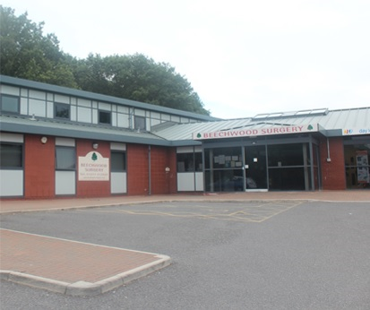 | 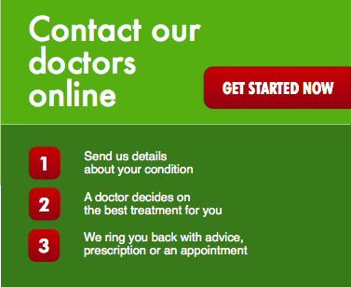
We are confident that our website will provide clear and concise help and give our patients the information they require in an easy and convenient format. It has been designed with the patient’s needs at the forefront of everything, from checking surgery times to letting us know what you think of us.

